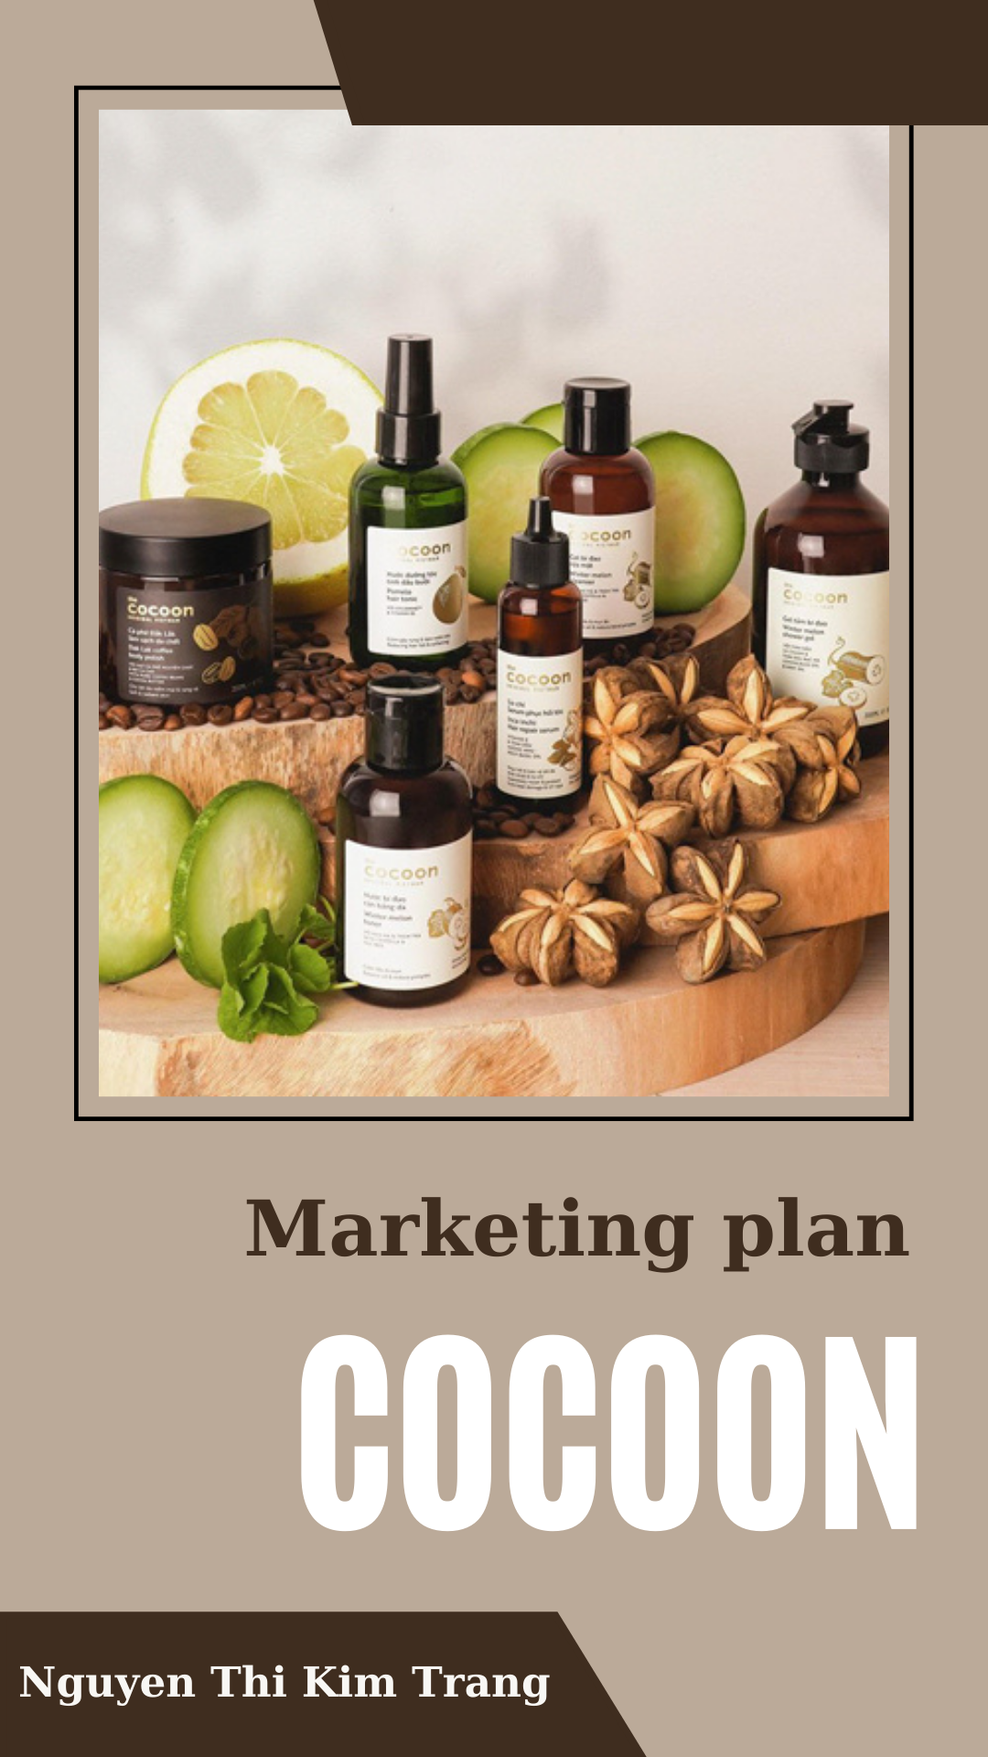

**TABLE OF CONTENT**

**I. INTRODUCTION 4**

**1. Theory 4**

**2.2. What is Marketing? 4**

**2.3. What is Digital Marketing? 5**

**2.4. What is 5Cs Model ? 5**

**2.5. What is STP ? 5**

**2.6. What is 7Ps Model ? 5**

**2. Cocoon 6**

**2.1. About Cocoon 6**

**2.2. Product line 6**

**2.3. Mission 7**

**2.4. Vision 7**

**2.5. Objective 7**

**2.6. Target 7**

**II. 5C MODEL 8**

**1. COMPANY: 8**

**2. CUSTOMER: 8**

**3. COMPETITOR: 9**

**3.1. Direct Competition 9**

**3.2. Indirect competitors 11**

**4. COLLABORATOR 11**

**4.1. Animal Asia Foundation 11**

**4.2. Suboi- Queen of hip-hop music in Vietnam 12**

**4.3. CoCoon's raw material supply partners 13**

**4.4. Retailers 13**

**5. CLIMATES: 13**

**5.2. The Economic Environment: 14**

**5.3. The Nature Environment: 14**

**5.4. The Technological Environment: 15**

**5.5. The Political Environment: 15**

**5.6. The Culture Environment: 15**

**III. STP 16**

**1. Segmentation: 16**

**2. POSITIONING: 18**

**2.1. Positioning map: 18**

**2.2. Points of difference (PODs) and Points of Parity (POPs) 19**

**IV. 7P 19**

**1. PRODUCT: 19**

**2. PLACE: 20**

**3. PRICE 21**

**4. PROMOTION 21**

**5. PEOPLE 22**

**6. PROCESS 22**

**7. PHYSICAL EVIDENCE 23**

**V. SWOT 23**

**VI. PLANNING DIGITAL MARKETING FOR COCOON’S BODY SCRUB PRODUCT LINE 24**

**1.1. Target customer 24**

**1.2. Market overview 24**

**1.3. Timeline and Frequency 24**

**1.4. Goal 26**

**1.5. Budget 26**

**1.6. KPIs 28**

**2. Marketing strategy 29**

**2.1. Main idea 29**

**2.2. Insight 29**

**2.3. Promotion of Campaign 29**

**2.4. Short Animation 31**

**2.5. Social plan (From 18/5 - 5/6/2023) 32**

**2.6. Poster & banner 32**

**2.7. Booking KOLs 34**

I. INTRODUCTION

1. Theory
   1. What is Marketing?

Marketing refers to any actions a company takes to attract an audience to the company's product or services through high-quality messaging. Marketing aims to deliver standalone value for prospects and consumers through content, with the long-term goal of demonstrating product value, strengthening brand loyalty, and ultimately increasing sales.

* 1. What is Digital Marketing?

[Digital marketing](https://marketbusinessnews.com/financial-glossary/digital-marketing/), also called online marketing, is the promotion of brands to connect with potential customers using the internet and other forms of digital communication. This includes not only [email](https://mailchimp.com/email-marketing/), [social media](https://mailchimp.com/marketing-glossary/social-media-marketing/), and web-based advertising, but also text and multimedia messages as a marketing channel.

* 1. What is 5Cs Model ?

5C Analysis is a marketing framework to analyze the environment in which a company operates. It can provide insight into the key drivers of success, as well as the [risk exposure](https://corporatefinanceinstitute.com/resources/knowledge/finance/what-is-systemic-risk/) to various environmental factors. The 5Cs are Company, Collaborators, Customers, Competitors, and Context.

* 1. What is STP ?

STP marketing is an acronym for Segmentation, Targeting, and Positioning – a three-step model that examines your products or services as well as the way you communicate their benefits to specific customer segments.

In a nutshell, the STP marketing model means you [segment your market](https://www.yieldify.com/blog/types-of-market-segmentation/), target select customer segments with marketing campaigns tailored to their preferences, and adjust your positioning according to their desires and expectations.

* 1. What is 7Ps Model ?

The marketing mix is one of the marketing strategies organizations have traditionally used to sell their product. To lay the groundwork, the marketing mix is defined as a collection of marketing techniques that a firm uses to promote its brand or product in the marketplace.

The approach was typically structured around the four pillars of marketing: product, price, location, and promotion. However, as marketing became more sophisticated, so have the approaches.  Later, it was expanded to 7Ps of marketing with the inclusion of People, Process, and Physical Evidence.

To drive marketing choices at every level, businesses materialize  the aspects of the marketing mix. It assists them in:

- Recognizing its assets and mitigating its flaws

- Becoming more adaptive and competitive

- Improving departmental and partner collaboration

1. Cocoon
   1. About Cocoon

- Company: Nature Story Cosmetics Ltd

- Cosmetics Brand: Cocoon

- Established in 2013

- Website: myphamthuanchay.com

- Email: vegan.cocoon@gmail.com

- Phone number: 0972 383 373

Cocoon means "cocoon", the cocoon is like a "house" that is easy to cuddle, nurturing a sleeping worm to one day turn into a beautiful and gorgeous butterfly.

From such a meaning, Cocoon is an easy "home" to take care of the skin and hair of Vietnamese people, helping them become more beautiful, perfect and shining in their own way. Cocoon was born with a simple reason to beautify Vietnamese people from familiar and close sources of ingredients.

Cocoon cosmetic brand is famous for its cosmetics and beauty products from 100% natural. The manual production process says no to preservatives and harmful chemicals. With the application of modern technology, but still complying with and improving the secret beauty recipes in the ancient court, the cost is low, but cocoon's products are safe and highly effective beauty solutions.

The cocoon manufacturing company specializes in the production of natural beauty products. The production company always adheres to traditional production processes. Clean tools after use and manufacture the most meticulous and guaranteed.

Cocoon products have been tested and certified for safety by the Pasteur Institute in Ho Chi Minh City. As a result, cocoon's products are an effective beauty secret trusted by many people.

* 1. Product line

Cocoon is very diverse in many different cosmetic lines, in order to serve the many needs of each customer.

|  |  |
| --- | --- |
| Product line | Specific products |
| Hair care | Hair conditioner, shampoo, conditioner... |
| Facial care | Moisturizers, makeup removers, cleansers, toners, scrubs,  toners, masks... |
| Body care | Shower gel, body lotion, hand sanitizer, and body scrub, ...... |
| Lip care | Lip balms, lip scrubs..... |

* 1. Mission

Beautify Vietnamese people from close and familiar sources. Nature is very favorable to nature in Vietnam, we are a world of extremely rich plants from fruits to herbs, inside they contain valuable nutrients that are not only delicious to eat but also delicious. Very good for the skin and hair. Therefore, Cocoon researches and constantly produces 100% pure cosmetic products that keep all the nutrients of Vietnamese plants, safe, and benign, do not use ingredients from animals, and say no to testing. Animal name test.

* 1. Vision

Cocoon was born to give you once skin, a bouncy hair that is always healthy, youthful, and full of life from simple and close ingredients that you eat every day.

Cocoon always has one mission in mind: applying the benefits of the food around us combined with understanding science to create safe and effective cosmetic products for everyone. The arduous journey to true beauty is not your own task, Cocoon will accompany you on that journey. Forever like that, forever like that.

* 1. Objective

To build an image of a pure cosmetic brand that comes from Vietnam, making it easy for users to feel the Vietnamese soul in each product, and at the same time affirming the beauty of Vietnam's nature, as well as the quality of its products. The amount of cosmetics coming from Vietnam's nature compared to other countries in the world is not inferior.

* 1. Target

Building the image of a pure cosmetic brand that comes from Vietnam, making it easy for users to feel the Vietnamese soul in each product and at the same time affirming the beauty of Vietnam's nature, as well as the quality of cosmetics. coming from the nature of Vietnam compared to other countries in the world is not inferior.

In Vietnam, spas have become more popular in recent years, providing different products and services but still meeting the wishes of customers. At a spa, customers already pay for services to take care of their skin, so they won't buy skin care products.

Cocoon also has hair growth products that are extracted from grapefruit. To wait for the results, customers have to persevere in using the product for many months for hair growth. Instead of this method, some people want to have their hair done at hair salons, where they can have long hair within a day.

1. 5C MODEL
   1. COMPANY:

**Business goals**

Cocoon's mission is to create completely vegan products without animal origin to meet the expectations of the Vietnamese people: safe and effective.

**Style, desired business image when appearing on the market**

Cocoon - vegan cosmetic brand "Made in Vietnam". The company has caught up with the beauty trend that is extremely popular in the world today, which is Vegan (vegan) and Cruelty Free (not tested on animals) by using extremely "pure Vietnamese" ingredients to bring into its product. This has helped Cocoon stand out in the market.

**100% Vegan Product**

Cocoon is a leading brand in the vegan cosmetics trend in Vietnam with international certificates that ensure the safety of its products' 100% vegan ingredients. Therefore, Cocoon is known by many people for its humane and safe products for users' health. That is a huge difference between the brand and other cosmetic companies on the market.

**Environmentally friendly brand image.**

All Cocoon products use packaging that is both beautiful and environmentally friendly. The brand also makes "green commitments" such as:

Packaging made from friendly paper.

Cocoon says no to microplastics.

The product bottles are all recyclable.

Do not use plastic coating for product packaging and bottles.

These moves help Cocoon improve the reputation and sympathy of customers for the brand.

=> Cocoon successfully created the image of a good quality Vegan Cosmetics brand Made In Vietnam.

**Brand personality:** Friendly, safe and natural

Cocoon is a leading brand in the vegan cosmetics trend in Vietnam with international certificates that ensure the safety of the products' 100% vegan ingredients. Therefore, Cocoon is known by many people for its humane and safe products for users' health.

* 1. CUSTOMER:
* Gender: Female.
* Geographical location:  living in big cities like: Ho Chi Minh City, Hanoi, Da Nang, Hai Phong
* Age: Cocoon's target audience is mainly 18-24 year olds
* Income: Belongs to Group A Class (under 5 million VND) and Group B Class (5 - 12 million VND)
* Education: Focus on the group of Colleges (College); University (University); Post-graduate.
* Usage behavior: Cocoon's target customer usually buys 1-2 times/month.
* Psychology:

Belongs to the personality group Approachable, friendly, open and Careful, thoughtful, sensitive.

* Prefer products with natural ingredients. The trend of green living is gradually becoming popular, now young people prefer to use products of clean origin that do not harm the environment.
* Buy for beauty needs.

1. COMPETITOR:

In markets, Cocoon marketers must be aware of the advantages of both direct and indirect competitors in forging relationships and attracting attention from the same target audience.

3.1. Direct Competition

|  |  |  |  |
| --- | --- | --- | --- |
|  | https://lh5.googleusercontent.com/NqplIUz0LrEmpCSyb0KRx5fwx8_wDZ9h51id3LGzDRp3xGOfbCiPFKbrTwpE4pcCc6JACbapGm5aRZJdu_hIiYTw2Uw2FYPQPrHnBFhvuUkUr8NN_eAa59Lc0nrsEpHNRXyZQinnxk9iU3U | https://lh4.googleusercontent.com/Ou9dgSDO7x_VU9G-iOyovp6Kloy8zMeaBtfCYzTlQbsa68cFedzhO1taAaPFRtxgH4kF1meLz4XBufWXJ3Nle7SVQE92EK3O35_NM4zNoyO33P9fI7b8nnj8OK2iRiDXI6IlxwfBg3PBm30 | https://lh4.googleusercontent.com/1-rdN9MPufsdC8MSJpcbKS-JiloZCCI_WiYC6lK8y2l7Llx6Df32n9Nsntli78bkQ2SHcD8L4peTjVSDlqOhwp1ViOcwiuPeprUcKfUr-Trjdl7pRSB02HGMdbDIdG04uiGShbv4ioT4MKE |
| **Brand** | **Cocoon** | **The body shop** | **Dove** |
| **National**  **origin** | VietNam | UK | US |
| **Brand Awareness Index** | Low | High | High |
| **USP** | Functional:  Produced from vegan natural ingredients  Emotional:   * Safety * Environmental friendliness * Vietnamese people support Vietnamese products. | Natural ingredients | Trusted long-standing brand |
| **Strengths** | - The advantage of available raw materials from Vietnam's nature such as squash, Dak Lak coffee, Ben Tre coconut, Cao Bang rose…  - Ingredient Vegan safe, benign, transparent product information right on the package with a clear commitment from the manufacturer, in terms of form and design.  -Review TOP 10+ tẩy tế bào chết body tốt nhất nên mua 2023 The product has a compact design so it is very convenient | - The body shop’s products are safe and healthy for the skin. With a reasonable price, a thorough and thoughtful investment in product quality and image  - Pleasant fragranceReview TOP 10+ tẩy tế bào chết body tốt nhất nên mua 2023This article is referenced content from https://chanhtuoi.com - Review TOP 10+ tẩy tế bào chết body tốt nhất nên mua 2023 | - Healthy and safe natural ingredients  - A  thorough and thoughtful investment in product quality and image  - Careful packing |
| **Weakness** | - Small jar, used about 1 month is finished with a frequency of 2-3 times / weekReview TOP 10+ tẩy tế bào chết body tốt nhất nên mua 2023This article is referenced content from https://chanhtuoi.com - Review TOP 10+ tẩy tế bào chết body tốt nhất nên mua 2023 | - It's a bit wasteful  - High price | - The design of the plastic jar is not beautiful.  - There is no protective plastic cover inside.  - The full size price is a bit high compared to other exfoliating products on the market. |

3.2. Indirect competitors

In Vietnam, spas have become more popular in recent years, offering different products and services that still meet the needs of customers. At a spa, customers already pay for services to take care of their skin, so they won't buy skin care products. Cocoon also has hair growth products that are extracted from grapefruit. To wait for the results, customers have to persist in using the product for many months for hair to grow. Instead of this method, some people want to have their hair done at hair salons, where they can have long hair within a day.

1. COLLABORATOR

4.1. Animal Asia Foundation

Cocoon has officially announced the cooperation with Animals Asia (AAF) in the program "Together to protect bears" to launch a limited edition of Dak Lak Coffee product that cleans dead skin on the body.  This is one of the leading and reputable organizations in calling for an end to bear farming, as well as concern and improvement of the rights of this endangered animal.  With each limited product sold, the brand will contribute a part to the retirement fund of Animals Asia in Vietnam. Vietnamese bear households (Tam Dao National Park, Vinh Phuc).

Launching a LIMITED VERSION “JOIN END TO END ELEPHANT RAITING” for Dak Lak coffee cleansing products on November 1, 2022. The products will be dressed in a dark green "new shirt" - the color of the lush jungles, the words "JOIN END WILDING ELEPHANTS" are pressed and printed prominently to inspire the same. Dak Lak elephant conservationist started with STOP Riding ELEPHANTS.

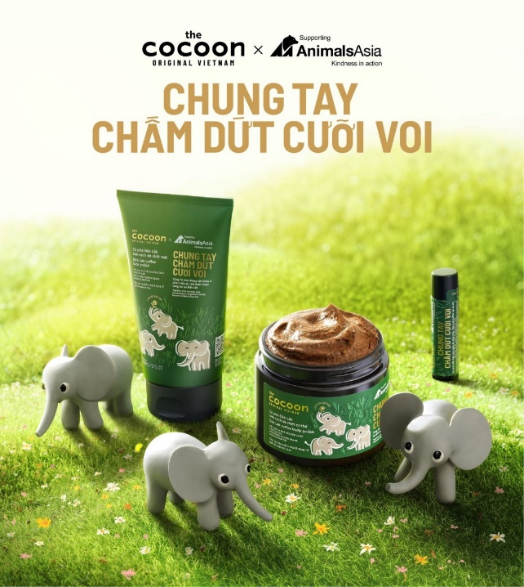

4.2. Suboi- Queen of hip-hop music in Vietnam

On the occasion of October 20, CoCoon and Suboi launched a collection of products to remove dead skin cells from Dak Lak coffee called "Queen" Chất. They want to send an impressive message to users: “Queen” Quality – there is always a queen present in yourself. Proud and proud. Different and unique.

CoCoon's raw material supply partners must adhere to Leaping Bunny's standards, commit to not testing on animals in the process of creating that material, including the transparent production process and must provide testing methods to ensure this ingredient is safe to be used in cosmetic formulations.

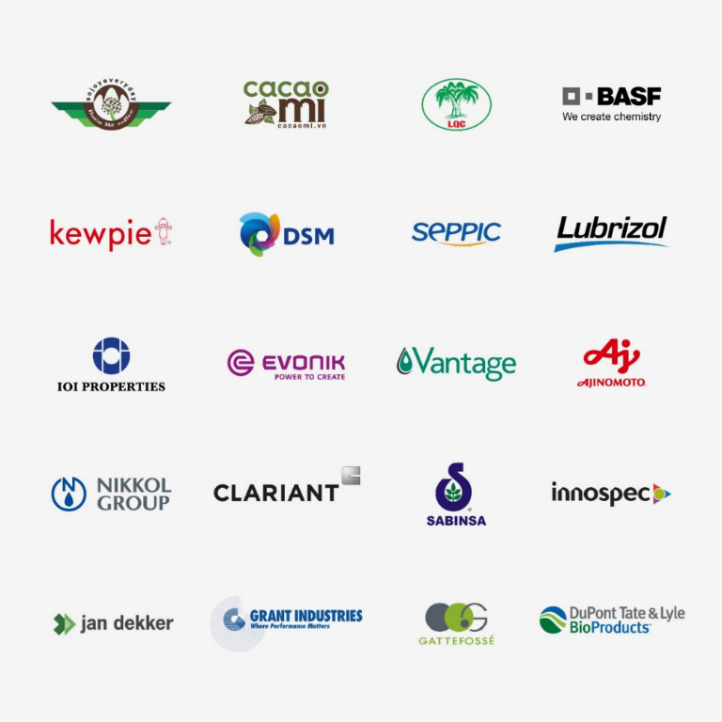

4.3. CoCoon's raw material supply partners

Must adhere to Leaping Bunny's standards,commit to not testing on animals in the process of creating that material, including the transparent production process and must provide testing methods to ensure this ingredient is safe to be used in cosmetic formulations.

4.4. Retailers

Cocoon does not have its own store, in order to reach customers as much as possible, Cocoon chooses to cooperate with partners and make its products more widely available.

Business cooperation helps develop a business or meet current business needs, because business cooperation also brings a lot of benefits such as saving costs, increasing business

opportunities.

Currently, Cocoon has "covered" more than 300 points of sale at leading cosmetic distribution systems in Vietnam, some familiar names to customers such as Hasaki, The Guardian, Watson...

1. CLIMATES:

**5.1. The Demographic Environment:**

Vietnam has a large population and age to use cosmetics (full 15 to 65 years old) account for a high 69.3% of the national population => high demand for beauty

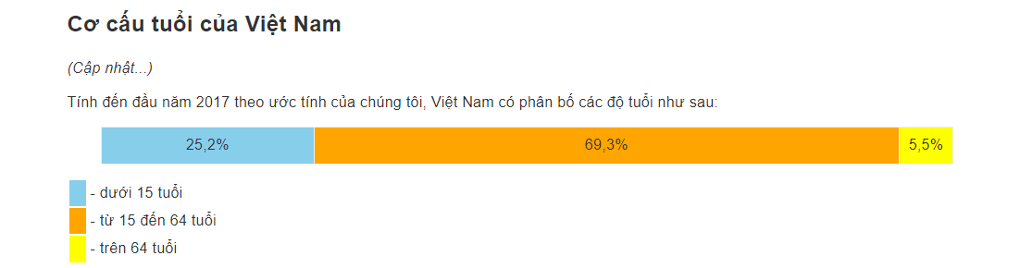

The shifting population: Population growth in large cities has created a potential market for commercial activities.

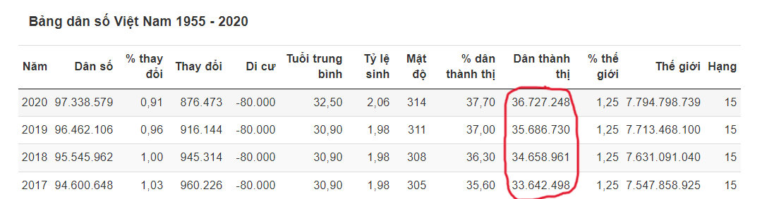

=>That's one of the reasons Cocoon allocates stores and distributors concentrated in big cities

5.2. The Economic Environment:

Consumer price index (CPI) in January 2023 increased by 0.52% over the previous month and by 4.89% over the same period in 2022. Core inflation in January 2023 increased by 5.21% over the same period. previous year period (cre: https://www.gso.gov.vn/)

=>This affects the price of raw materials and the cost of Cocoon products. At the same time, it will also affect the purchasing behavior of consumers as product prices increase.

Changes in consumer spending:

The average monthly income of employees in the fourth quarter of 2022 is VND 6.8 million, an increase of VND 95 thousand compared to the previous quarter and an increase of VND 1.5 million compared to the same period last year.

=> Rising incomes lead people to spend more on outsourced, branded products and services and the rate of expenditure on essential products will decrease.

5.3. The Nature Environment:

After the Covid 19 epidemic, customers' buying habits changed: online shopping rates increased, consumers were more strict in choosing consumer products, emphasizing natural products, good for health.

Climate change and increasing environmental pollution affect the skin and hair of people: black, tanned,dandruff hair,..Don’t worry, Cocoon has got the product that will solve the consumer moral problem.

The input materials of Cocoon cocoons are derived from nature. Therefore, the quality of raw materials is easily affected by environmental factors such as weather, climate, and pests... This becomes a difficult problem that requires Cocoon to have a solution.

5.4. The Technological Environment:

With the introduction of modern machines and developing technology, Cocoon can apply to the production line, speeding up the completion speed as well as improving product quality.

Cocoon comply with and improve the traditional recipes, the secret to beauty, the meticulous processing stages, and always clean and disinfect contact instruments during production.

Using the secret formula from Tue Tinh with modern manufacturing technologies, Cocoon has produced high levels of zucchini and some pods, which help to treat acne, freckles, and skin white.

5.5. The Political Environment:

Legislation regulating business:

The legal system is increasingly complete and synchronized. The State of Vietnam has many laws covering issues such as competition, fair trade practices, environment protection, products safety,…

5.6. The Culture Environment:

Shift in secondary cultural values: People’s views of themselves: Everyone is unique in their own way, they use products, brands and services as a means of self-expression. Cocoon is a great choice for those who want safety, love nature and animals

People’s view of the Universe: Religion has always been the subject of interest and control. The Buddhists want to eat vegetarian and do good so Cocoon is an amazing product.

=> Marketers needs to concern more about advertising strategies, and product introductions with the right color, and design.

Patriotism and national pride of Vietnamese people: supporting Vietnamese branded products

II. STP

* 1. Segmentation:

|  |  |  |  |
| --- | --- | --- | --- |
|  | Object 1 | Object  2 | Object 3 |
| Gender | Female | Female | Female |
| Age | 18-24 | 24-30 | >30 |
| Income | < 5 million | 5-12 million | >12 million |
| Geographical location | The biggest cities: Ho Chi Minh City, Hanoi, Danang,... | The biggest cities: Ho Chi Minh City, Hanoi, Danang,... | The biggest cities: Ho Chi Minh City, Hanoi, Danang,... |
| Behavioral characteristics, shopping attitudes. | * Love to explore and experiment with exfoliating products of different brands. * Shopping behavior is easily influenced by KOLs, KOCs or hot products in the market * National spirit: Vietnamese support Vietnamese goods | * Pay attention to the ingredients in the product. Especially with a love for natural ingredients (eg: grapefruit, locust, coffee, coconut oil ...) * National spirit: Vietnamese support Vietnamese goods | * Loyalty to good quality products that have been used. * Be selective, research carefully before making a decision to buy beauty products. * There is interest in the natural ingredients of beauty products like the old grandparents. * National spirit: Vietnamese support Vietnamese goods |
| Benefits that customers are looking for | The product has the basic use of an exfoliating product.  Good price. | The product is effective, does not cause skin irritation.  The price is commensurate with the quality. | High requirements for product quality, ensuring benign for the skin |

Target: Object 1:

|  |  |
| --- | --- |
|  | Object 1 |
| Gender | Female |
| Age | 18-24 |
| Income | < 5 million |
| Geographical location | The biggest cities: Ho Chi Minh City, Hanoi, Danang,... |
| Behavioral characteristics, shopping attitudes. | * Love to explore and experiment with exfoliating products of different brands. * Shopping behavior is easily influenced by KOLs, KOCs or hot products in the market * National spirit: Vietnamese support Vietnamese goods |
| Benefits that customers are looking for | The product has the basic use of an exfoliating product.  Good price. |

2. POSITIONING:

2.1. Positioning map:

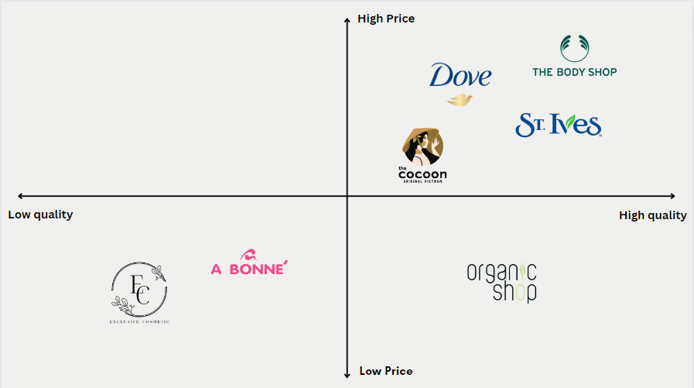

* Positioning by product attributes: Cocoon's products are considered as "healthy foods" that bring beauty to people, 100% vegan with safe and effective quality. Features a compact design that is very convenient, viscous, medium enough seeds, when removed, does not cause skin irritation, mild coffee aroma.
* Positioning by price: Focusing on the mid-range segment, Cocoon's products also carry a fairly cheap price. Only 125.00 VND/ 200ml jar for Dak Lak Coffee exfoliant, 165,000 VND per 200ml jar for Exfoliating Coffee Coffee Palm sugar is enough for you to use from 2-3 months
* Positioning by user: Cocoon's products bring to users with clear origin, benign and safe for the skin. Make users feel more secure with familiar ingredients in the daily life of Vietnamese people from vegetables and fruits.
* Positioning by competitors:

|  |  |  |
| --- | --- | --- |
| **The firm** | **Product** | **Price** |
| Where | Dove Exfoliating Body Polish | 200.000 VND/298g |
| Cocoon | Daklak coffee Body Polish | 125,000VND/200ml |
| St.ives | St.ives fresh Skin Apricot Scrub | 135,000 VND/283g |
| The body shop | Olive Body Scrub | 599.000 VND/250ml |
| Organic Shop | Organic Coffee and Sugar Body Scrub | 120.000 VND/250ml |
| Exclusive Cosmetic | Gel Scrub Coffee & Cinnamon Cloves | 100.000 VND/380g |
| Good | A Bonne Spa Milk Salt | 45.000 VND/350g |

2.2. Points of difference (PODs) and Points of Parity (POPs)

|  |  |
| --- | --- |
| **PODs** | **POPs** |
| Vegan product, committed not to test on  animals. Towards a green, healthy lifestyle  from the smallest things. | Product packaging made of paper without  plastic coating is environmentally friendly,  say no to microplastics, the product bottle  can be recycled. |

1. 7P
2. PRODUCT:

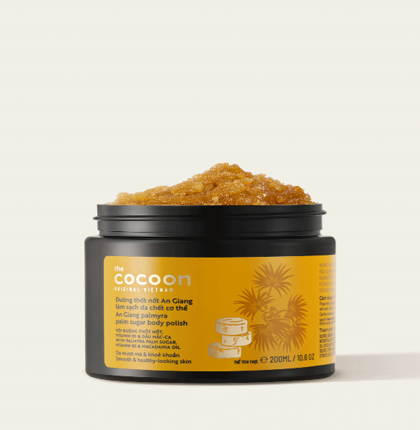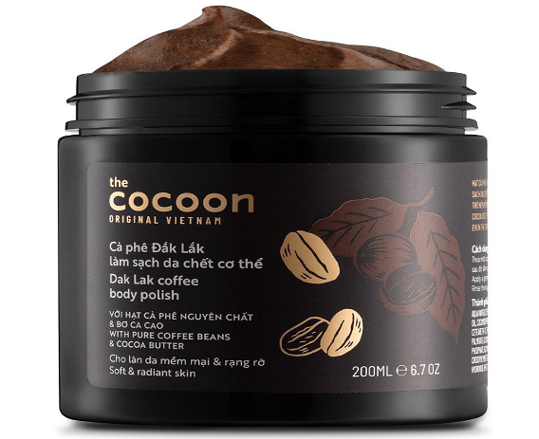

a. Core products:

* With Cocoon's body scrubs, the core layer of the product is:
* Removes dead skin cells.
* Improve skin pigmentation, smooth skin.
* Prevents flaking and dry skin

1. General products:

* As for the exfoliator, it's about helping the skin become firm, even-toned, providing more energy for the skin to stay soft and radiant.

1. Expected product:

* Exfoliating the body needs to really remove layers of old dead skin cells, leaving the inherent smoothness and health of the skin.

1. Supplementary products:

* The product is fortified with pure coffee beans, cocoa butter, jaggery crystals, vitamin B5 and macadamia oil.Has strong antioxidant properties that help prevent free radicals that are the cause of skin aging, support healing of skin lesions, reduce atopic dermatitis, have high moisturizing ability, reduce stretch marks, soften skin and improve calloused areas.
* Service elements:
* Invest in cocoonvietnam.com website with interface get its own highlight.
* Dedicated and enthusiastic consulting team
* Distribution through many e-commerce platforms such as Shopee, Lazada, Tiki, TikTok,...
* Mainbooksellrow:TDo not believe the invoice on the outside of the package always has the brand's girl logo to identify the products as genuine.

1. Potential products:

* The company's products are committed to using 100% natural ingredients,No sulfates, no mineral oils, no parabens, no microplastics increasingly gaining the trust of users. Therefore, it is an effective and safe exfoliant for the body

1. PLACE:

Distribution channel: (with pictures included)

Cocoon has no retail stores. Instead, Cocoon products will be sold directly at partner stores such as Con Cung, Hasaki, Guardian, Beauty Garden,...

Other distribution channels are through e-commerce sites, websites, Social media (facebook, tiktok, instagram)

Advantage:

Reach a large number of potential customers

Avoid price hikes because there are no direct retail stores.

Disadvantages: Consumers easily mistakenly buy fake Cocoon products of poor quality, reducing the brand's reputation.

1. PRICE

With the line of Body Scrub products, there will be different prices equivalent to different product weights.

With combos, customers will feel more profitable when buying retail, this is the strategy of "Combo Marketing"

With the price of the 200ml type can:

* Easy entry into the exfoliating product market
* Compete with direct and indirect competitors
* The price allows potential customers to try the product.

1. PROMOTION

Create Gamification with meaningful message (Tạo ra các Gamification với những thông điệp đầy ý nghĩa)

* Marketing campaign “Khám Phá Việt Nam”

- This is a combination of Social Media Ads (advertising on social networks) and Gamification (gaming), we can understand this as a way of marketing in the form of Minigames, but Cocoon is extremely smart when integrating it. those are images associated with local regions of Vietnam. This helps to increase the trust of customers and win everyone's love when building a unique brand image in the current cosmetic market (Unique here is towards environmental protection). , the commitment associated with Cocoon).

* Minigame “Vì động vật cần được yêu thương”

- Just like the Vietnam Discovery Campaign, this time Cocoon continues to assert itself, when it has just been approved in its commitment to testing on animals by Cruelty Free International's Leaping Bunny program. decided to launch the mini game "BECAUSE OF ANIMALS NEED TO BE LOVED" with the message of wanting to spread humane values ​​for animals. This is really a clever message given to the minigame when it wants to let people know more about itself in order to build a better image of the brand than ever with the certification of Leaping Bunny.

* Live Green With Cocoon Every Day – Program “Đổi vỏ chai cũ, nhận sản phẩm mới”

- Is an annual program of Cocoon for users to lead a sustainable green lifestyle every day and contribute to protecting the natural environment from the threat of waste, with the message that it wants to convey is with the cooperation of For each individual, old cosmetic bottles and bottles will no longer be "trash" when they are recycled, reused and can start a "new life". Although the program is simple, it brings a more sympathetic look than ever to the image of Cocoon.

=> Not only is a vegan cosmetics company with a commitment to beauty and health, Cocoon is also a brand that positively inspires users when implementing many meaningful programs such as: “Campaign to plant trees from plastic jars. old Cocoon on earth day 2020", "Exchange old bottles and receive new products" with messages and purposes of environmental protection, saving electricity,... attracted more than 7000 participants, this has helped the company not only increase sales but also increase brand awareness and promote many new products to consumers.

1. PEOPLE

It's necessary and you have to recruit and train the right people whether it's someone in support, customer care, copywriters, programmers.

Mainly focus on customer relationship management, because the audience is mainly students - genZ students, Cocoon employees focus on marketing on social platforms, KOL,... mostly used by genZ.

Customers can directly contact Cocoon support for product advice at Cocoon's website, official social networking sites, hotline or direct mail => From there, build a relationship. Contact with customers, increase reliability and professionalism, create a position in the hearts of customers.

1. PROCESS

Cocoon Vietnam has a nationwide delivery service, applicable to customers who buy products on Website, Fanpage and call Cocoon's Hotline. Orders will be delivered to the address provided by the customer through an intermediary shipping agency, ECO DELIVERY or 247EXPRESS. In particular, the invoice information on the outside of the package always has the brand's girl logo to identify the products as genuine.

Delivery time

a. Orders within Ho Chi Minh City: Delivery time is 2-3 days after placing the order.

b. Orders in the suburbs of Ho Chi Minh City and other provinces: The time is 2-5 days for the city center and 5-6 days for the district, commune, town...

c. However, there are still limitations and delays due to objective reasons such as holidays, Tet, difficult to find delivery addresses, delays from delivery services, etc. Cocoon hopes for your understanding for reasons beyond our domination.

d. In case there is a delay in delivery, Cocoon will immediately notify you and will continue to deliver or support order cancellation if you want. We will not be responsible for delivery delays except for refunds if you have paid but have not received the product.

1. PHYSICAL EVIDENCE

Customers have the right to rest assured when shopping as well as being able to meet all their beauty needs, exchange and return goods when having problems.

Products are distributed to retailers such as Watson, Guardian, Hasaki etc. to help customers easily shop and have more choices.

The product has a compact design so it is very convenient, transparent product information right on the package with a clear commitment from the manufacturer, in terms of form and design.

1. SWOT

|  |  |
| --- | --- |
| **STRENGTHS** | **WEAKNESS** |
| * Deep brand value * Modern production lines and techniques * Beautiful product design * Diversified product support services * Quality product, affordable price * Wide distribution channels | * There are not many attractive promotions yet * Brand promotion is still at a normal level * The design is large, so it is difficult to carry it for travel * The creation of product quality is still limited |
| **OPPORTUNITIES** | **THREATS** |
| * The vegan cosmetic market is interested and is growing strongly * Golden population structure, the majority of young people * The development of e-commerce | * The situation of counterfeit goods is mixed * Lots of competitors * High consumer expectations * Natural disasters and environmental pollution affect |

1. PLANNING DIGITAL MARKETING FOR COCOON’S BODY SCRUB PRODUCT LINE
   1. **Marketing Objectives**

1.1. Target customer

The customer that CoCoon wants to target is "young adults" because the demand for this market segment in Vietnam is very large.

Directly targeting women's concerns is to always be beautiful anytime, anywhere, at the same time, World Environment Day is coming up June 5 - launched to convey the message and build a sustainable, fun lifestyle and harmony with nature.

1.2. Market overview

More than 86% of respondents regularly use skin care products, and 40% of women over 23 take care of their skin daily. Women between the ages of 15 and 39 are about 11 million people, accounting for 40% of the female population, so this market segment is very fertile and full of potential. According to the poll, women in big cities are also willing to spend more on cosmetics and skin care. The 23-29 age group spends the most on skin care. The current beauty trend is eco-friendly solutions such as recycled materials, “natural” design to protect nature, the environment and encourage sustainable living.

Understanding customer desires and Cocoon's advantage, Cocoon adopted a Focus Marketing Strategy to focus on a well-defined market. Because this targeted marketing

strategy requires Cocoon to better serve a defined market segment than their competitors.

1.3. Timeline and Frequency

In 2023, Cocoon will deploy digital marketing strategies on social media and

e-commerce platforms through each period and event of the year. As a vegan cosmetic

brand, Cocoon is really interested in environmental protection events so that he can create

communication campaigns to increase brand awareness and brand trust of customers.

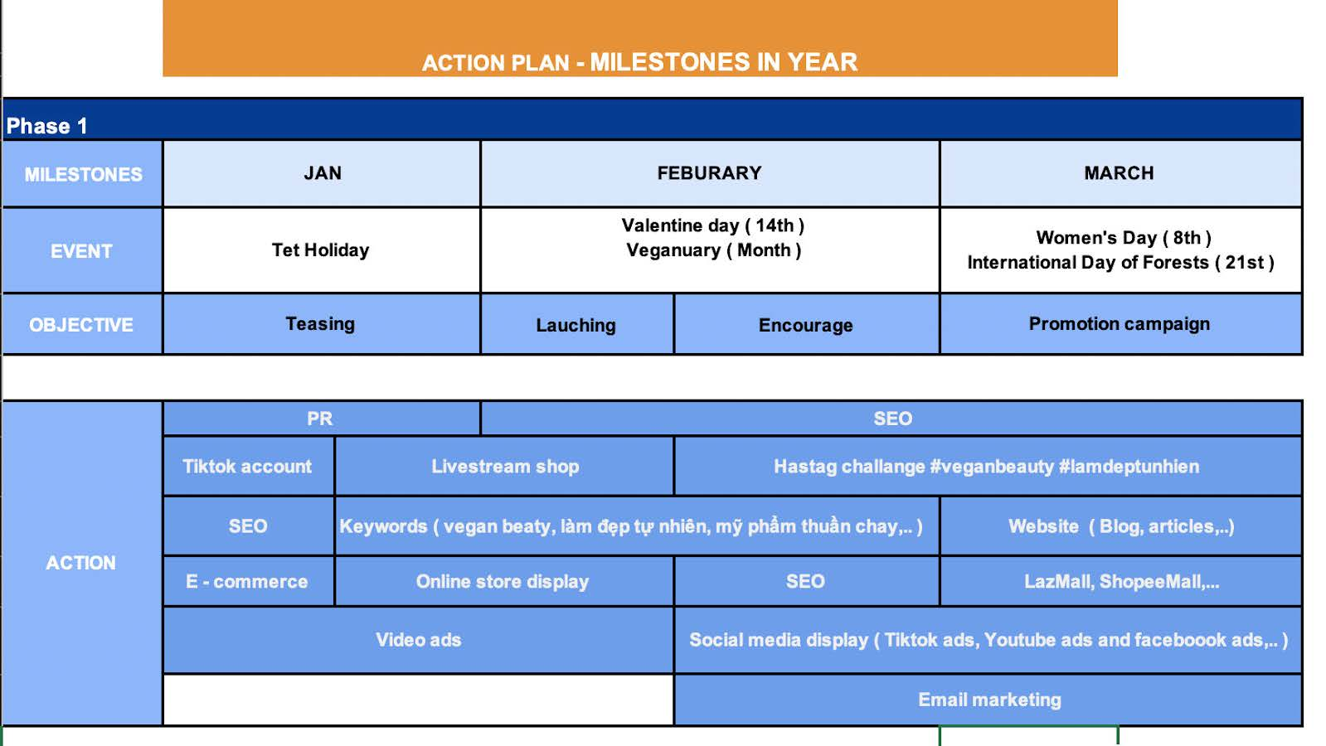

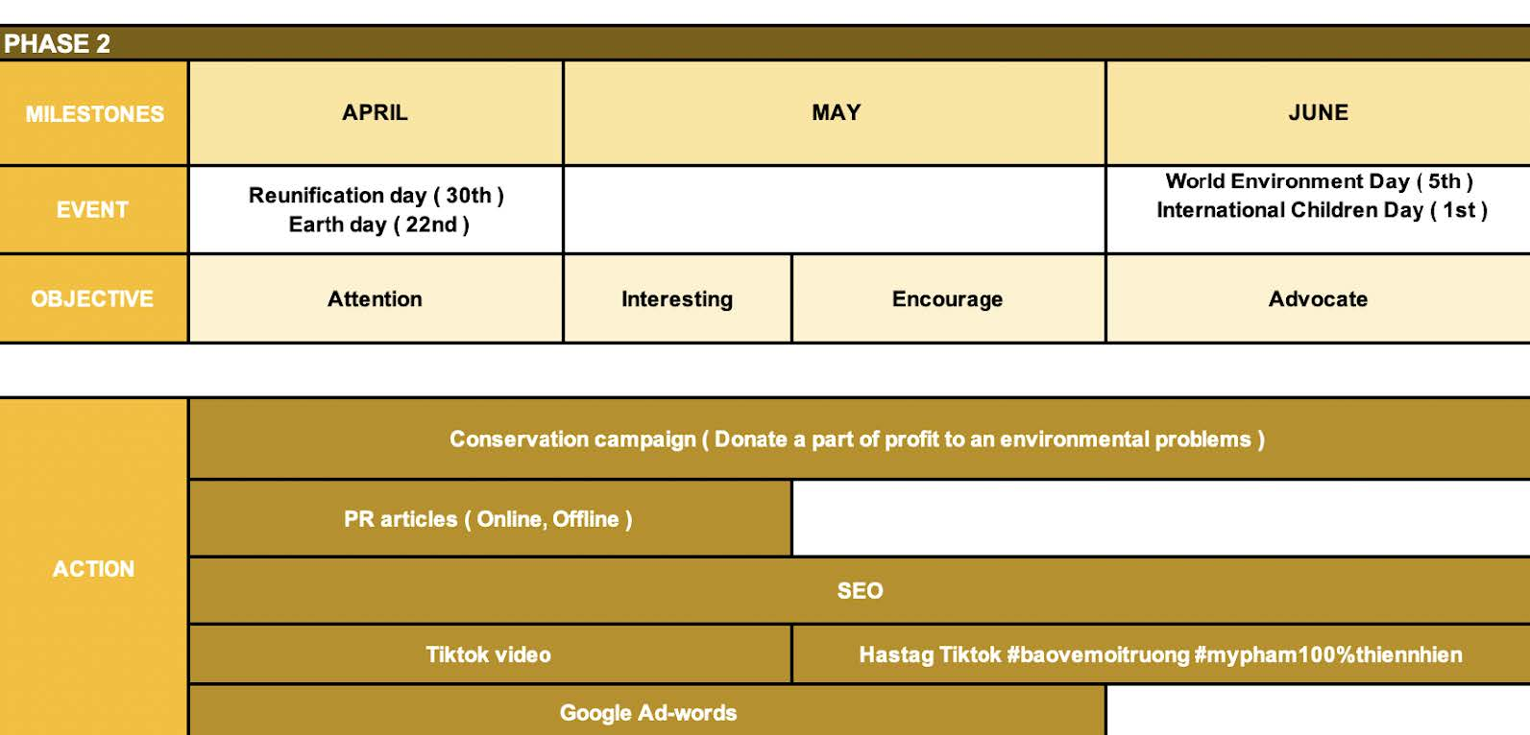

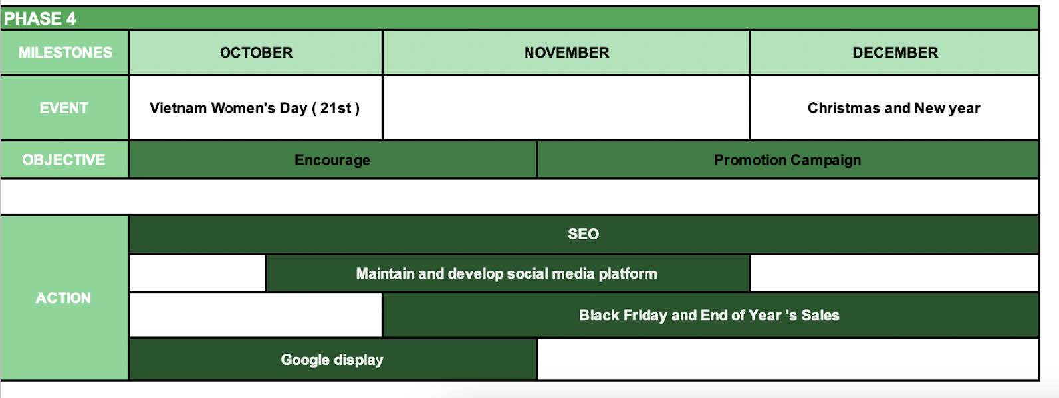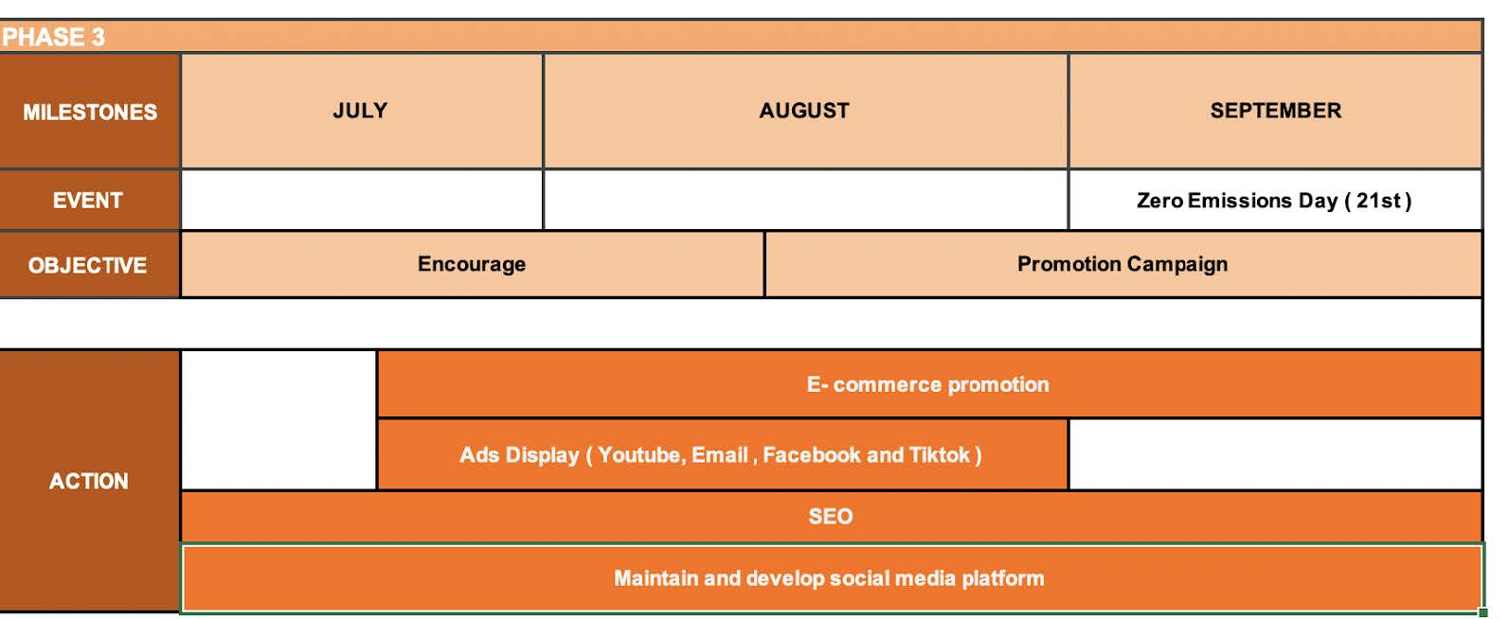

1.4. Goal

**Business goals**

- 10% revenue growth in 2023.

- Increase the brand's market share by 8% in the vegan cosmetics market.

**Marketing goals**

- Increase brand awareness on social media.

- Increase coverage at retail points

- Top of mind in vegan cosmetic brands

- Calling on the whole world in general and the customer community of Cocoon in particular to respond to World Environment Day.

1.5. Budget

To reach the success it is now, Cocoon has implemented a lot of marketing strategies to increase brand awareness and attract customers. Because the effectiveness was tested in

2022, Cocoon divided the majority of the budget among social media, e-commerce and

influencer marketing channels (48%, 8% and 12% respectively). Customer behavior

changes, they tend to hunt for sales on special occasions or on the same month, so 18% of

the budget will be for promotion programs. Cocoon does not have strengths in Website

and Search Engine Marketing (SEM), so it only maintains the budget for these programs

at 5%. In addition, invest in CRM and Omnichannel systems (Haravan, Zalo OA,

Mailchimp) to manage multi-channel orders and take care of the brand's customers.

|  |  |  |  |
| --- | --- | --- | --- |
|  | Quantity | Project per unit(VND) | Project subtotal(VND) |
| Facebook | 4 | 35,000,000 |  |
| Instagram | 4 | 15,000,000 |
| Tiktok | 8 | 25,000,000 |
| Social media |  |  | 75,000,000 |
| Shopee | 1 | 40,000,000 |  |
| Tiktok Shop | 1 | 35,000,000 |
| Lazada | 1 | 20,000,000 |
| E-commerce |  |  | 95,000,000 |
| Hà Linh Official | 1 | 25,000,000 |  |
| Call me Duy Official | 1 | 27,000,000 |  |
| Luna Dao Official | 1 | 35,000,000 |  |
| KOLs/ Influencers/ Affliate |  |  | 87,000,000 |
| SEO | 1 | 25,000,000 |  |
| PPC | 1 | 15,000,000 |  |
| GG Adwords | 1 | 18,000,000 |  |
| Search Engine Marketing (SEM) |  |  | 58,000,000 |
| Haravan | 1 | 600,000 |  |
| Mailchimp | 1 | 5,000,000 |  |
| Zalo OA | 1 | 3,840,000 |  |
| CRM system |  |  | 9,440,000 |
| Short Animation | 1 | 40,000,000 | 40,000,000 |
| Discount | 4000 | 15,000 |  |
| Freeship | 5000 | 20,000 |  |
| Voucher | 2500 | 15,000 |  |
| Promotion |  |  | 197,500,000 |
| TOTAL COST |  |  | 561,940,000 |

1.6. KPIs

In order to determine specific and right KPIs, Cocoon needs to ensure the criteria of the

SMART principle:

Specific : Based on the brand's strategic and business goals

Measurable: Measure traffic on owner media (social media, e-commerce platform and

website) Achievable : Positioning the brand "made in Vietnam" with a variety of vegan cosmetics

and cosmetics, beauty technology is always R&D, KPIs can be achieved with a growth

rate of 3 - 8% per quarter depending on the index.

Relevant: digital marketing strategies deployed quarterly to collect traffic (visit, reach)

and increase leads.

Timebound : Time is divided into 4 quarters of the year and determine what to do in

section 2.3 Timeline and Frequency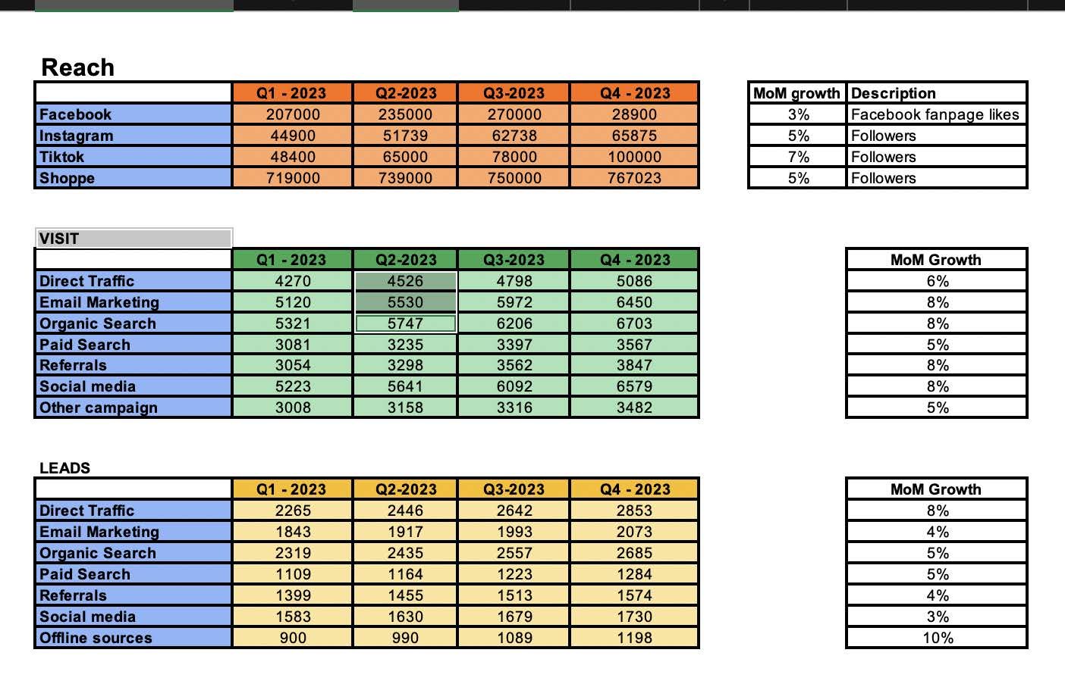

With the development of the Tiktok platform, Cocoon focuses on building content routes

(viral videos, short videos and livestreams) to increase impressions and reach the target of

100,000 followers on Tiktok. About Facebook, continue to maintain and run advertising

campaigns of the brand. In the Visit and Lead section, Cocon needs to develop through

Organic Search, Social media and Direct Traffic. Currently, Cocoon still uses E-commerce platform links in each brand's content on social media platforms. But the development of Tiktok shops and E-commerce helps brands reduce a lot of costs from paid media.

2. Marketing strategy

2.1. Main idea

- Campaign for **World Environment Day** Environment Day: responding to World Environment Day - Living green every day with Cocoon.

“PHÁ KÉN”

The image of a butterfly cocoon represents a girl crouched in misery, self-deprecating with rough skin – after knowing and using Cocoon's body scrub products, regaining her confidence with healthy skin – strongly **"Phá kén"** and transform into a beautiful butterfly freely flying in the blue sky.

- Content format: Posts, Short Animation, Images (Poster, Banner, Packaging products).

2.2. Insight

- Directly targeting women's concerns is to always be beautiful anytime, anywhere, at the same time, World Environment Day is coming up June 5 - launched to convey the message and build a sustainable, fun lifestyle and harmony with nature.

- Cocoon wants through this campaign to call the whole world in general and Cocoon's customer community in particular to also respond to this meaningful day. Just experienced the duo of Body Scrub  products that exfoliate the skin to effectively clean the body's dead skin, even out the skin tone, arouse energy to help the skin become soft and radiant with natural ingredients, contribute to environmental protection.

2.3. Promotion of Campaign

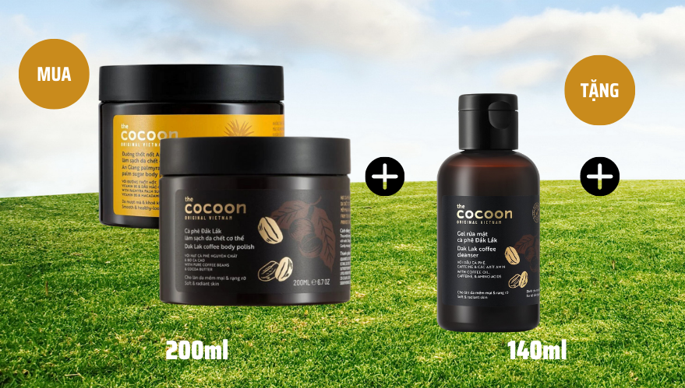

Buy 1 set of Cocoon products to Body Scrub, get 1 free coffee gel clean.

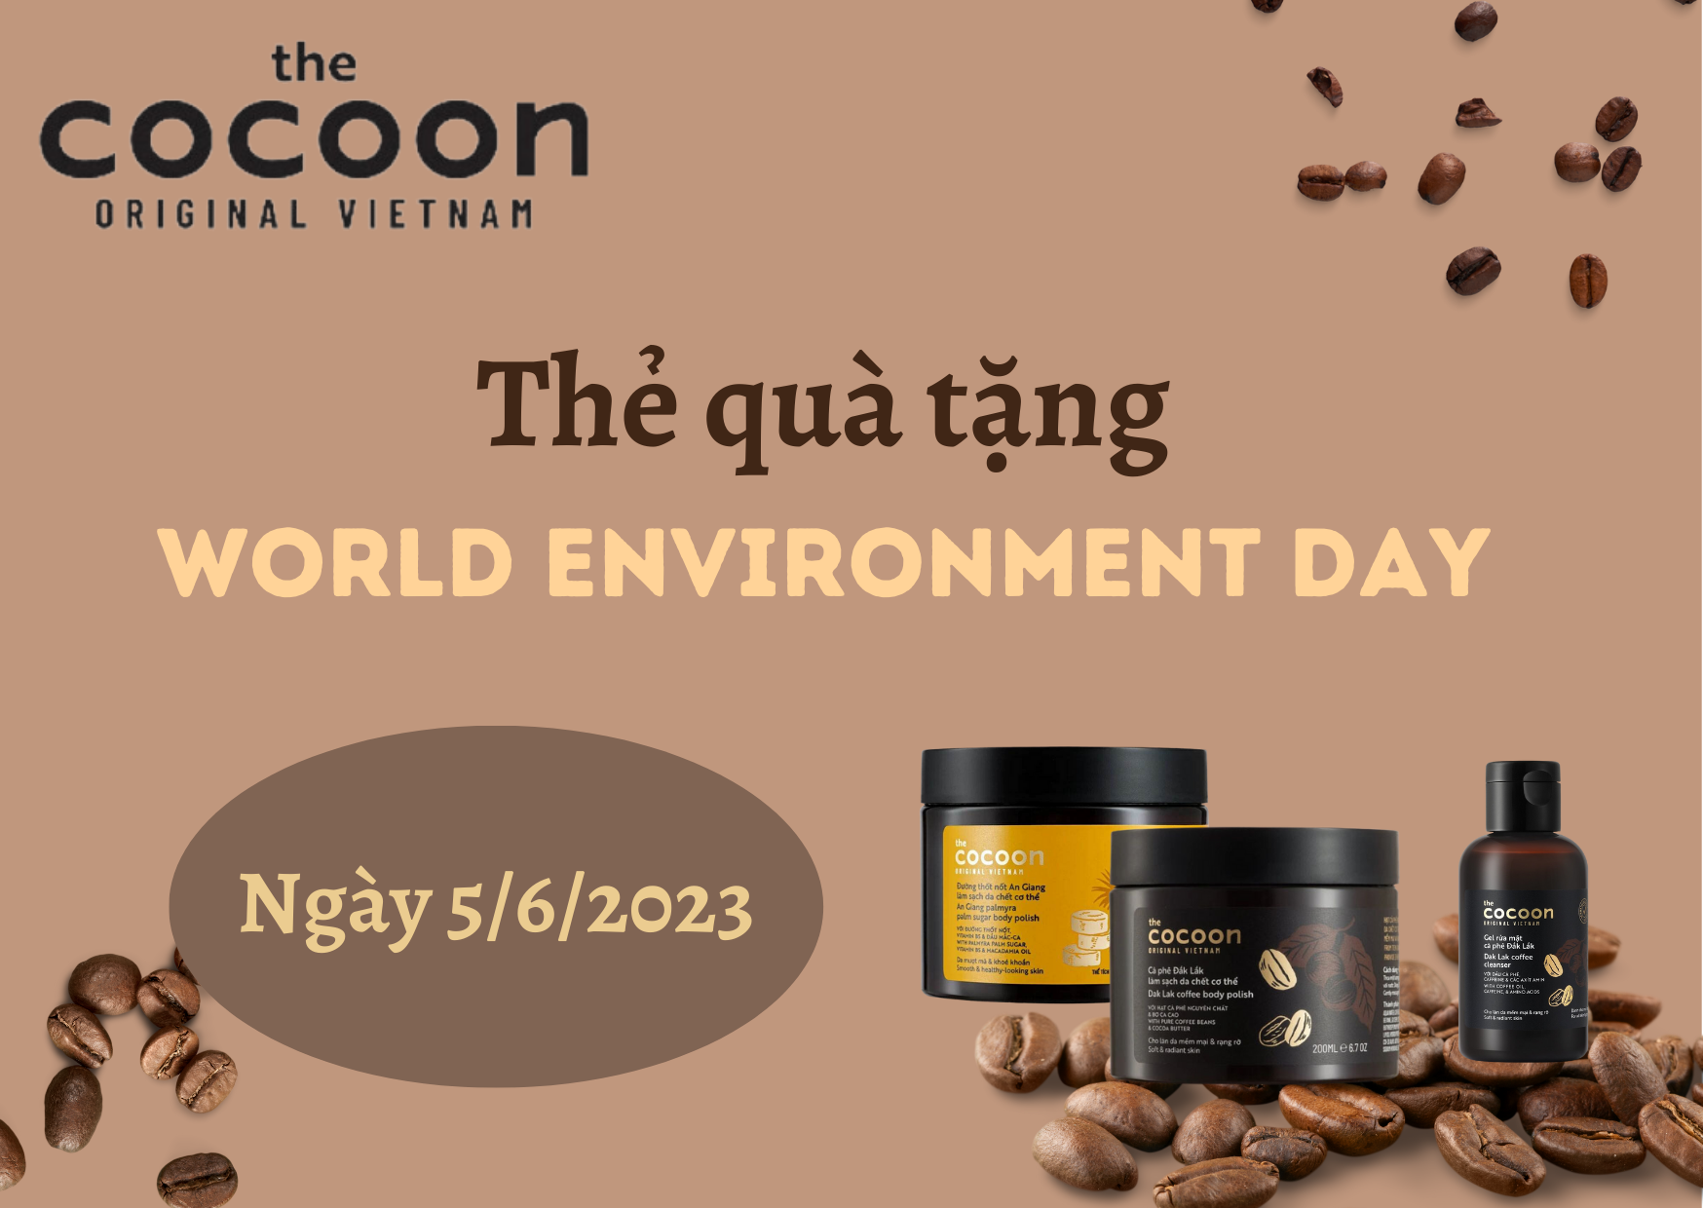

Gift card included with the set to redeem the gifts during the event on 05/06/2023

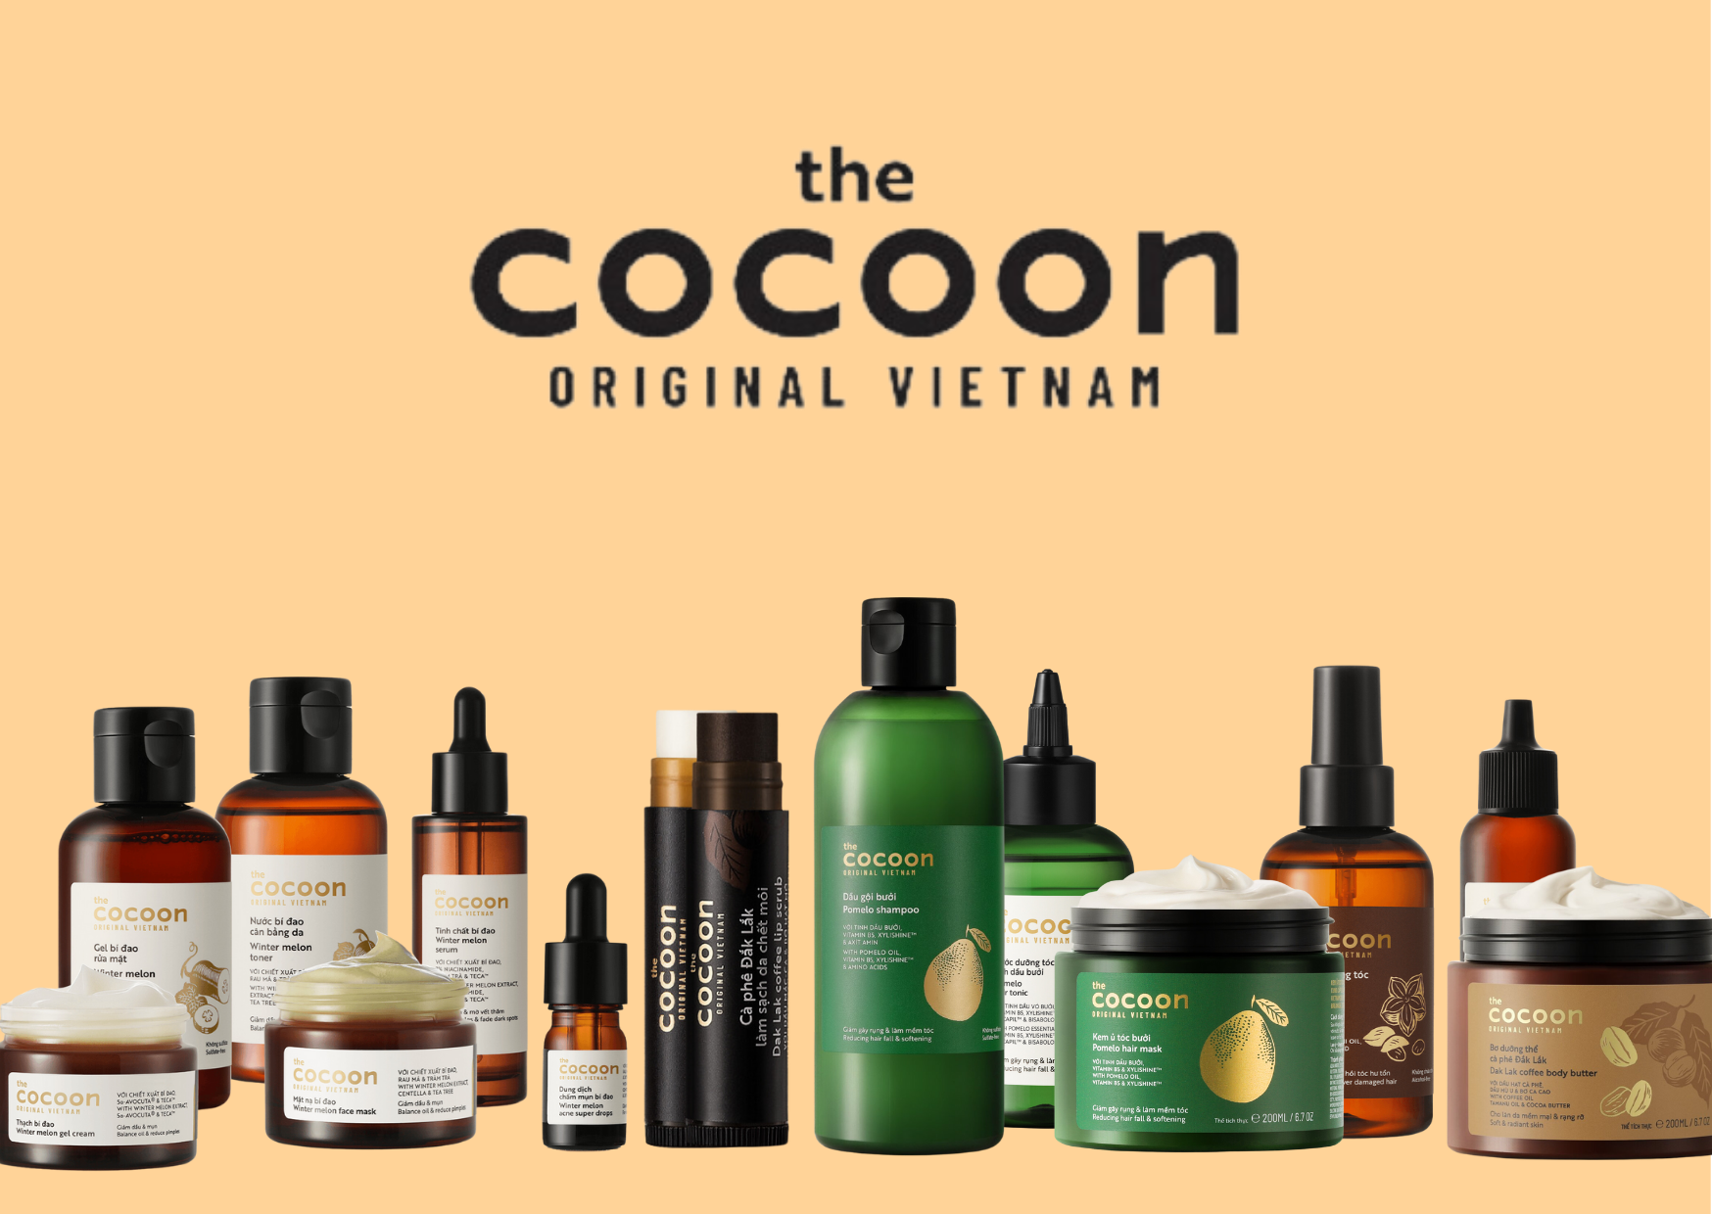

Products that can be exchanged for gift cards There are also some other handmade items such as recycled plant pots,...

2.4. Short Animation

- Post on platform**:**  Facebook, Instagram, Tiktok

- Two main characters**:** The Green Fairy - representing the environment, The Butterfly Lady – Cocoon

 

**Green Fairy Butterfly Lady**

- Summary**:** Once upon a time, the green fairy protected and nurtured the butterfly cocoon, so that one day the beautiful butterfly broke the cocoon and returned the favor, helping the green fairy.

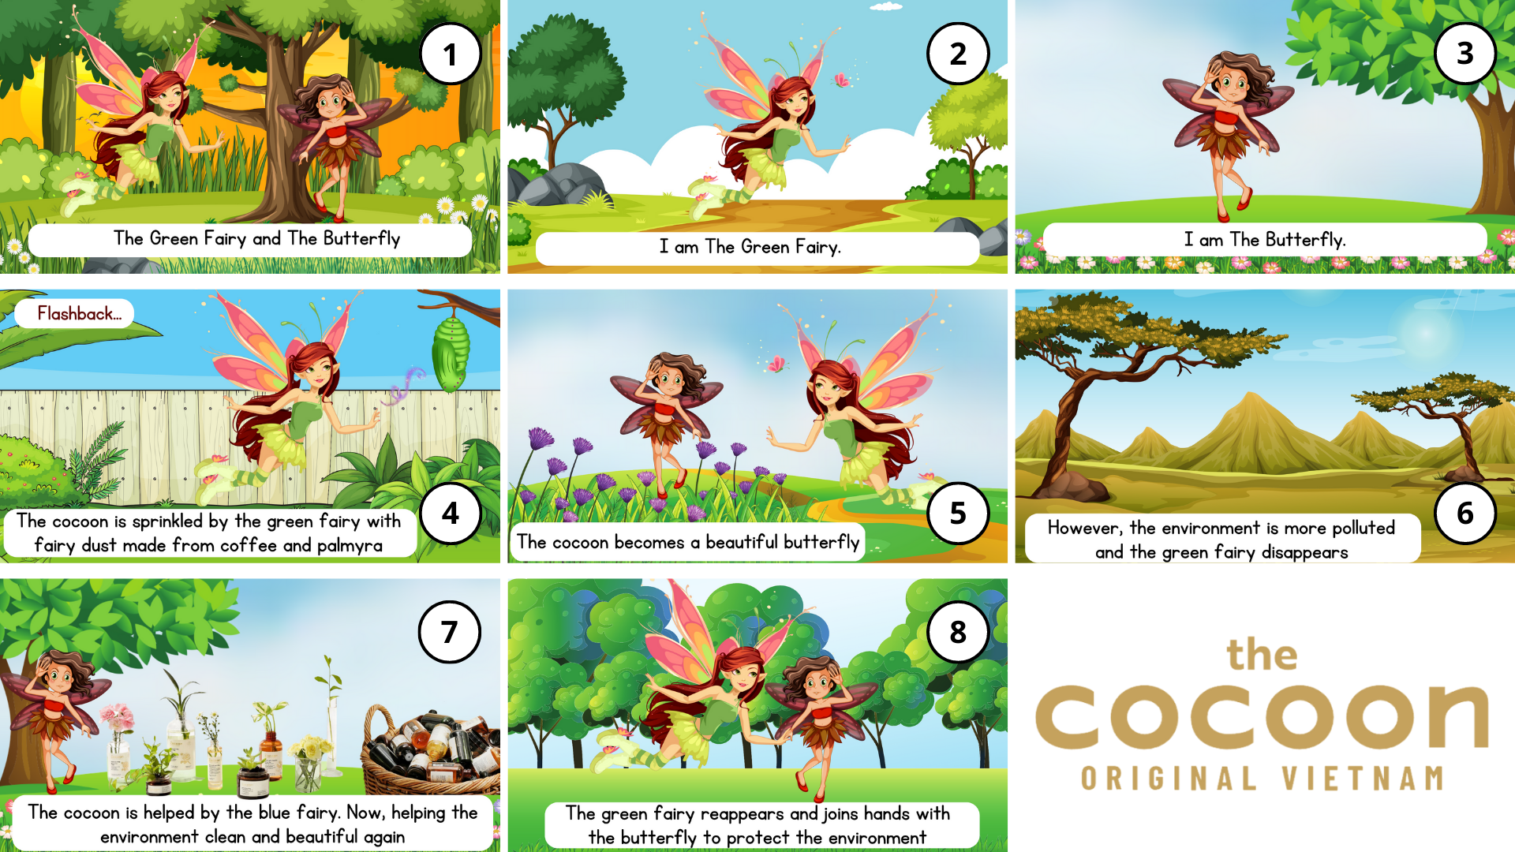

2.5. Social plan (From 18/5 - 5/6/2023)

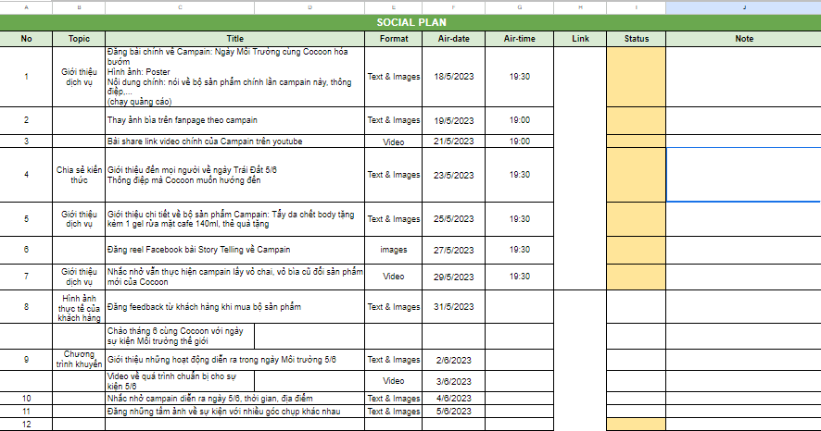

2.6. Poster & banner

Post on platform: Facebook, Instagram

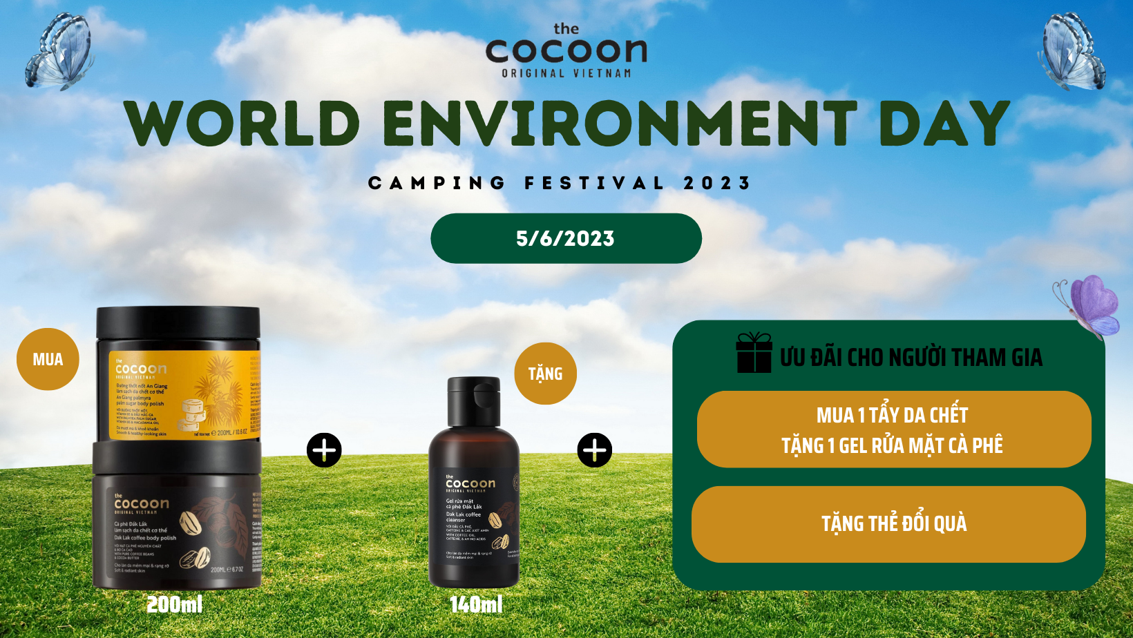

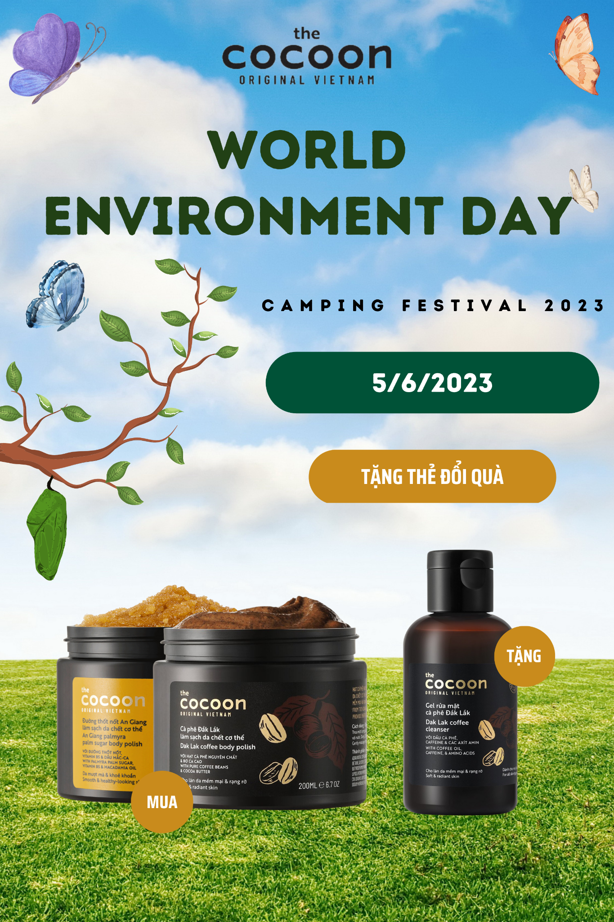

2.7. Booking KOLs

|  |  |  |  |  |
| --- | --- | --- | --- | --- |
|  |  | Format | Channel | Quantity |
|  | Hà Linh Official  - Facebook: 1,7 milions  - Youtube: 1,9 milions | Post, Clip | Facebook, Youtube | 1 Post, 1 Clip |
|  | Call me Duy Official  - Facebook: 96,000  - Youtube: 539,000 | Post, Clip | Facebook, Youtube | 1 Post, 1 Clip |
|  | Luna Dao Official  - Facebook: 1,7 milions  - Youtube: 495,000 | Post, Clip | Facebook, Youtube | 1 Post, 1 Clip |

**REFERENCES**

Giang Hương, Chương trình " Thu hồi pin cũ - Bảo vệ trái đất xanh", <https://www.cocoonvietnam.com/bai-viet/diem-thu-hoi-pin>

Cocoon, Câu chuyện thương hiệu, https://cocoonvietnam.com/trang/cau-chuyen-thuong-hieu

Hoa Hồng, Cocoon x AAF: Chung tay bảo vệ loài gấu cùng Tổ chức Động vật Châu Á, <https://cocoonvietnam.com/bai-viet/cocoon-x-aaf-chung-tay-bao-ve-loai-gau-cung-to-chuc-dong-vat-chau-a>

Hoa Hồng, 3 bước tẩy da chết hiệu quả dành cho mặt từ cà phê, <https://cocoonvietnam.com/bai-viet/3-buoc-tay-da-chet-hieu-qua-danh-cho-mat-tu-ca-phe-dak-lak>

Hương Thủy, Cocoon – tự hào thương hiệu việt nam tiên phong cho xu hướng mỹ phẩm thuần chay, <https://dep.com.vn/cocoon-tu-hao-thuong-hieu-viet-nam-tien-phong-cho-xu-huong-my-pham-thuan-chay/>

Tạp chí Phái đẹp ELLE, COCOON – “MỸ PHẨM THUẦN CHAY CHO NÉT ĐẸP THUẦN VIỆT”, <https://www.elle.vn/tin-lam-dep/cocoon-my-pham-thuan-chay-cho-net-dep-thuan-viet>

CHIẾN LƯỢC MARKETING CỦA COCOON – THƯƠNG HIỆU MỸ PHẨM THUẦN CHAY ĐƯỢC NHIỀU NGƯỜI QUAN TÂM, <https://www.navee.asia/kb/chien-luoc-marketing-cua-cocoon/>

Brade Mar, Khách hàng mục tiêu của Cocoon, <https://brademar.com/khach-hang-muc-tieu-cua-cocoon/>